|  |  |  |
| --- | --- | --- |
|  |  | **Information Sciences and Technologies**  **Golisano College of Computing and Information Sciences** |

hw19a: Photoshop

Editing and retouching photos in Photoshop  
Before you begin, you may want to turn on your history toolbar by going to window > history. This will allow you to see all the steps you’ve made and easily go back as far as you need.

#### Part 1: Clear the Beach

We are going to turn this crowded beach into a private beach using photoshop!  
Photo by [Michele Feola](https://unsplash.com/photos/A4-jvtqBKN8?utm_source=unsplash&utm_medium=referral&utm_content=creditCopyText) on [Unsplash](https://unsplash.com/?utm_source=unsplash&utm_medium=referral&utm_content=creditCopyText)

1. Open the image “beach.jpg” in Photoshop
2. You can try using the spot healing tool Macintosh HD:Users:anikaniva:Desktop:Screen Shot 2017-10-23 at 8.22.57 PM.png or the clone stamping tool Macintosh HD:Users:anikaniva:Desktop:Screen Shot 2017-10-23 at 8.23.03 PM.png to edit out everyone on the beach except for one small group of people (your choice who!)
3. When using the Spot Healing tool – make sure you paint each group of people you are editing out before releasing the mouse. Also, it’s best to edit them out in small groupings rather than large pieces at once- when drawing over, make sure to keep the brush relatively close to where the people you are removing
4. If you are using the Clone Stamping tool, remember that you hold down the “Option” key to select the target area and then you can paint over the area you want to erase and it will use the targeted area as a guide. It’s best to make sure the target area is as close to the group you are erasing as possible- there’s a lot more color variation in the beach than you may think and it shows!
5. Resize the image to be 800 pixels wide. You can adjust this by going to image > image size. The height should change in relation to the width so it doesn’t get stretched and warped- if it is getting stretched out, check to make sure height and width are linked when you are adjusting the image size- there is a picture of a little chain link and make sure it is selected.
6. Save the image as a JPEG (File > Export > Save for Web (Legacy)). Select JPEG from the drop down menu on the top right. This is an example of what your finished image should look like:  
     
   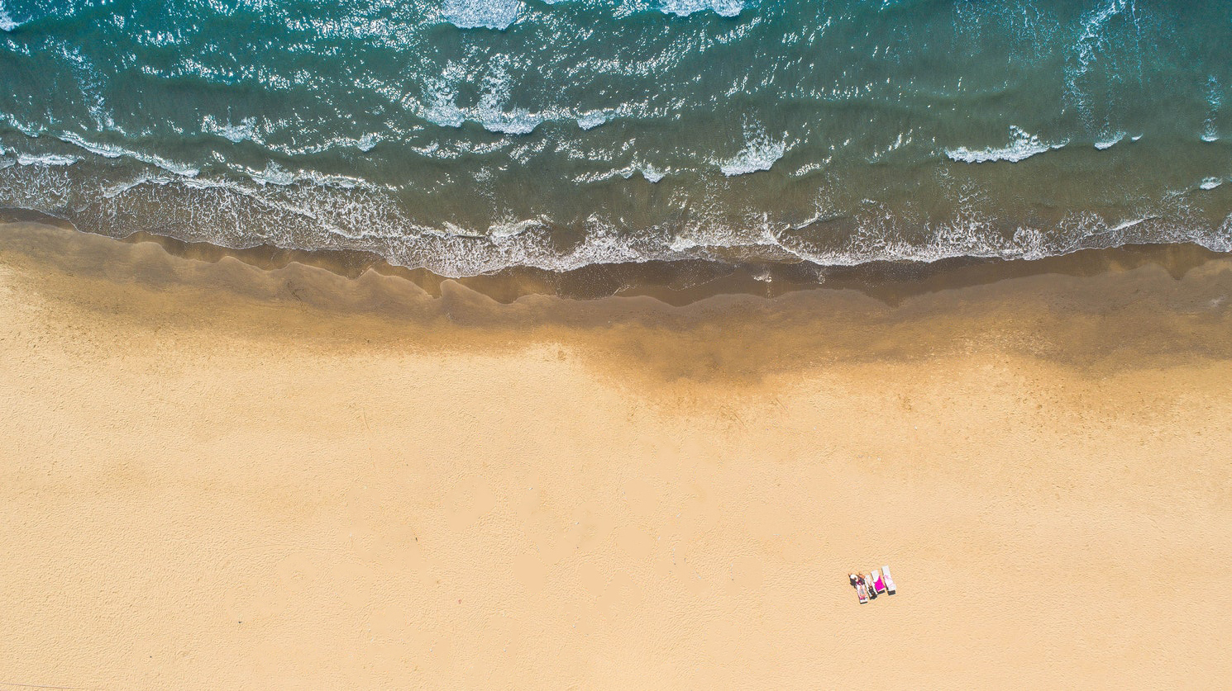

|  |  |  |
| --- | --- | --- |
| **hw19a: Beach Cleanup** | | |
|  |  |  |
| **Beach Retouching** | **Weight** | **Score** |
| Cleared the beach believably | 80 | **0** |
| Resized the image | 10 | **0** |
| Saved correctly as a JPEG | 10 | **0** |
| **Total Points** | 100 | **0** |